

AUTOMATIC WATER DISPENSER AND DUSTBIN (SMART HYGIENIC SYSTEM)

A PROJECT REPORT
Submitted by

SASHTIKA B SESAMWA TATENDA SHIYAMSUNDAR K S  THOOYAVAN L R | 23EE051  23EE053  23EE055  23EE063

In partial fulfillment for the award of the degree of

BACHELOR OF ENGINEERING
in

ELECTRICAL AND ELECTRONICS ENGINEERING

KPR INSTITUTE OF ENGINEERING AND TECHNOLOGY
(Autonomous Institution)

ARASUR, COIMBATORE 641 407
ANNA UNIVERSITY: CHENNAI 600 025
May 2025

BONAFIDE CERTIFICATE

Certified that this project report “automatic water dispenser and dustbin (smart hygienic system)” is the Bonafide work of “SASHTIKA B (23EE051) SESAMWATATEND (23EE053) SHIYAMSUNDAR K S (23EE055)
THOOYAVAN L R (23EE063) ” who carried out the project work under my supervision.

SIGNATURE
Dr.A.Mohamed Ibrahim Design Studio Coordinator Assistant Professor II Department of Electrical and Electronics Engineering, KPR Institute of Engineering and Technology, Arasur, Coimbatore-641407.

CHAPTER NO | TITLE | PAGE NO
 | LIST OF TABLE | 3
 | ABSTRACT | 1
1 | INTRODUCTION | 2-
2 | LITERATURE SURVEY
3 | PROBLEM IDENTIFICATION
4 | METHODOLOGY
5 | DESIGN AND FABRICATION
6 | FLOWCHART
7 | RESULT
8 | DESIGN OF SYSTEM
9 | CONCLUSION
10 | REFERENCE

ABSTRACT

AUTOMATIC WATER DISPENSER :
The Automatic Water Dispenser is a state-of-the-art system engineered to provide hygienic, touchless water dispensing in public and private spaces. Leveraging infrared sensors and microcontroller-based automation, the dispenser detects the presence of a user's hand and dispenses a predetermined amount of water, thereby minimizing waste and enhancing water conservation efforts. The system's design focuses on user convenience and hygiene, making it ideal for installation in schools, hospitals, offices, and public parks. Additionally, the integration of IoT technology allows for real-time monitoring of water usage and system performance, facilitating timely maintenance and ensuring uninterrupted service. This project not only addresses the need for efficient water management but also contributes to the broader goals of sustainability and public health.

AUTOMATIC DUSTBIN :
The Smart Dustbin is an innovative solution to modernize waste management through the integration of Internet of Things (IoT) technologies. Equipped with ultrasonic sensors, the dustbin continuously monitors its fill level and communicates this data to municipal authorities via GSM or Wi-Fi modules. This real-time communication enables efficient scheduling of waste collection, reducing operational costs and preventing overflows. Further enhancing its functionality, the Smart Dustbin features automated lid opening mechanisms activated by proximity sensors, ensuring hands-free operation and promoting hygiene. Advanced models incorporate waste segregation capabilities, sorting materials into categories such as wet and dry waste, thereby facilitating recycling efforts. The system's scalability and adaptability make it suitable for various environments, including urban centers, educational institutions, and healthcare facilities. By optimizing waste collection processes and encouraging responsible disposal practices, the Smart Dustbin contributes to cleaner, more sustainable communities.

CHAPTER 1 INTRODUCTION
In the contemporary landscape of urban development, the integration of automation and Internet of Things (IoT) technologies into everyday infrastructure is pivotal for enhancing efficiency, sustainability, and public health. This report explores two such innovations: the Automatic Water Dispenser and the Smart Dustbin, both designed to address critical challenges in resource management and waste disposal.

AUTOMATIC WATER DISPENSER:
The Automatic Water Dispenser is engineered to provide hygienic, touchless water dispensing, reducing the spread of contaminants and promoting water conservation. Utilizing infrared sensors and microcontroller-based automation, the dispenser detects the presence of a user's hand and dispenses a predetermined amount of water, thereby minimizing waste and enhancing water conservation efforts. The system's design focuses on user convenience and hygiene, making it ideal for installation in schools, hospitals, offices, and public parks. Additionally, the integration of IoT technology allows for real-time monitoring of water usage and system performance, facilitating timely maintenance and ensuring uninterrupted service. This project not only addresses the need for efficient water management but also contributes to the broader goals of sustainability and public health.

AUTOMATIC DUSTBIN:
The Smart Dustbin is an innovative solution to modernize waste management through the integration of Internet of Things (IoT) technologies. Equipped with ultrasonic sensors, the dustbin continuously monitors its fill level and communicates this data to municipal authorities via GSM or Wi-Fi modules. This real-time communication enables efficient scheduling of waste collection, reducing operational costs and preventing overflows. Further enhancing its functionality, the Smart Dustbin features automated lid opening mechanisms activated by proximity sensors, ensuring hands-free operation and promoting hygiene. Advanced models incorporate waste segregation capabilities, sorting materials into categories such as wet and dry waste, thereby facilitating recycling efforts. The system's scalability and

adaptability make it suitable for various environments, including urban centers, educational institutions, and healthcare facilities.

CHAPTER 2 LITERATURE SURVEY

AUTOMATIC WATER DISPENSER :
The evolution of automatic water dispensers has been significantly influenced by advancements in sensor technologies and microcontroller-based automation. Infrared (IR) sensors have been widely utilized to detect the presence of a user's hand, initiating the dispensing process without physical contact. This touchless operation not only enhances hygiene but also contributes to water conservation by dispensing a predetermined amount of water. Microcontrollers, such as Arduino and ESP32, serve as the central processing units, interpreting sensor inputs and controlling the dispensing mechanisms. Additionally, the integration of rechargeable lithium-ion batteries ensures portability and energy efficiency, making these dispensers suitable for various settings, including public spaces and residential areas.

Recent studies have explored the incorporation of Internet of Things (IoT) capabilities into water dispensers, enabling real-time monitoring and management. This integration allows for remote tracking of water usage, facilitating timely maintenance and ensuring optimal performance. Furthermore, the use of food-grade, corrosion-resistant materials in the construction of these dispensers ensures durability and compliance with health standards, thereby extending the lifespan and reliability of the devices.

KEY TECHNOLOGIES :
- Infrared (IR) sensors: Detect hand presence to activate the pump.

- Ultrasonic sensors: Monitor water levels in tanks.
- Microcontrollers (e.g., Arduino, Raspberry Pi): Control logic and sensor inputs.
- Peristaltic and submersible pumps: Used for water dispensing.

AUTOMATIC DUSTBIN:
The concept of smart dustbins has gained traction as urban areas face challenges related to waste management and environmental sustainability. Smart dustbins integrate various sensors, such as ultrasonic sensors for fill-level detection and moisture sensors for waste classification, to monitor and manage waste effectively. These sensors provide real-time data, which can be transmitted to municipal authorities or waste management systems via communication modules like GSM, Wi-Fi, or LoRa. This connectivity enables efficient scheduling of waste collection, reducing operational costs and preventing overflows.

The incorporation of automation features, such as servo motors for lid operation and compaction mechanisms, enhances the functionality of smart dustbins. These features ensure hands-free operation, promoting hygiene, and increasing the capacity of the bins, thereby reducing the frequency of waste collection. Additionally, the integration of solar panels as power sources contributes to the sustainability of these systems, making them suitable for deployment in various environments, including urban centers and remote areas.

KEY TECHNOLOGIES :
- PIR (Passive Infrared) or IR sensors: Detect motion near the lid.
- Servo motors: Used for lid actuation.
- Microcontrollers: Control sensor input and motor response.

- Ultrasonic sensors: Sometimes used for waste level detection.

CHAPTER 3 PROBLEM IDENTIFICATION

CHALLENGES WITH TRADITIONAL WATER DISPENSING SYSTEMS :
Traditional water dispensers, prevalent in public spaces and institutions, often present several issues:
- Hygiene Concerns: Manual operation of dispensers can lead to cross- contamination, especially in high-traffic areas.
- Water Wastage: Lack of precise control over water dispensing can result in excessive water usage.
- Maintenance Issues: Frequent breakdowns and the need for regular maintenance can lead to service interruptions.
- Inefficiency: Manual operation can be time-consuming, especially in settings with high user turnover.

CHALLENGES IN URBAN WASTE MANAGEMENT :
Urban areas face significant challenges in waste management, including:
- Overburdened Infrastructure: Existing waste management systems often struggle to cope with the increasing volume of waste.
- Inefficient Collection Systems: Traditional waste collection methods can be slow and inefficient, leading to delays and overflows.
- Lack of Segregation: Improper segregation of waste at the source complicates recycling efforts and increases landfill usage.

- Environmental Impact: Improper waste disposal can lead to pollution and health hazards.
- Resource Constraints: Limited resources and funding can hinder the implementation of effective waste management solutions.

AUTOMATIC WATER DISPENSER :

CHAPTER 4 METHODOLOGY

The development of the Automatic Water Dispenser integrates sensor-based automation with microcontroller technology to enhance user convenience and hygiene. The system employs an ultrasonic sensor to detect the presence of a container beneath the dispenser. Upon detection, the sensor triggers a solenoid valve to release water, ensuring touchless operation. The Arduino microcontroller serves as the central processing unit, interpreting sensor data and controlling the valve's operation. To ensure portability and energy efficiency, the system is powered by a rechargeable lithium-ion battery, with charging facilitated via a USB-C port. This design minimizes water wastage by dispensing a predetermined amount per activation and reduces the risk of cross-contamination in public settings.

Advanced methodologies include implementing a Temporal Clustering Algorithm (TCA) to predict user behavior and optimize energy consumption. The TCA analyzes historical usage patterns to anticipate peak demand times, enabling the system to adjust its operation accordingly and achieve energy savings of up to 40% compared to conventional modes of operation .

CIRCUIT DESIGN :
- The IR sensor is connected to a digital input pin on the microcontroller.

- The relay module is connected to a digital output pin.
- The pump is powered through the relay and controlled by switching logic.

AUTOMATIC DUSTBIN :
The Smart Dustbin system leverages Internet of Things (IoT) technology to optimize waste management processes. The system utilizes an ultrasonic sensor to monitor the fill level of the bin. When the fill level reaches a certain threshold, the system sends an alert to the municipal authorities, prompting timely collection. Additionally, a moisture sensor is employed to distinguish between wet and dry waste, facilitating appropriate segregation. The system's operations are managed by an Arduino microcontroller, which processes sensor data and controls the necessary actuators. Communication modules such as GSM or Wi-Fi are incorporated to transmit alerts and data to relevant stakeholders.

Advanced methodologies involve the integration of deep learning algorithms for waste classification. Models like WasteNet, based on convolutional neural networks (CNNs), can classify waste into categories such as paper, plastic, metal, and organic with high accuracy. Deploying these models on low-power devices at the edge allows for real-time decision-making without the need for cloud connectivity .

Furthermore, the system can incorporate IoT-based route recommendation algorithms to optimize waste collection schedules. By analyzing data from multiple smart dustbins, these algorithms can determine the most efficient routes for waste collection vehicles, reducing fuel consumption and operational costs .

CIRCUIT DESIGN :

- Ultrasonic sensor: Trig and Echo pins connected to digital I/O pins on the Arduino.
- Servo motor: Signal wire connected to a PWM-capable digital pin.
- Power: USB or external 5V source for microcontroller and servo.

CHAPTER 5
DESIGN AND FABRICATION

AUTOMATIC WATER DISPENSER:
DESIGN OVERVIEW :
The Automatic Water Dispenser is designed to promote hygiene and water conservation by automating the water dispensing process. The system utilizes an ultrasonic sensor to detect the presence of a container beneath the dispenser. Upon detection, a solenoid valve is activated to release water, ensuring touchless operation and minimizing water wastage.
COMPONENTS USED:
- Arduino Uno: Acts as the central controller for processing sensor inputs and controlling the solenoid valve.
- Ultrasonic Sensor (HC-SR04): Measures the distance between the sensor and the container to detect presence.
- Solenoid Valve: Controls the flow of water based on signals from the Arduino.
- MOSFET (IRF540N): Used as a switch to control the solenoid valve, as the Arduino cannot supply sufficient current directly.
- Power Supply: Provides the necessary voltage and current to the components.

FABRICATION PROCESS :
- Circuit Assembly: Connect the ultrasonic sensor, MOSFET, and solenoid valve to the Arduino according to the circuit diagram.
- Programming: Write and upload the Arduino code to detect the presence of a container and activate the solenoid valve accordingly.
- Enclosure Design: Design a waterproof enclosure to house the components, ensuring durability and safety.
- Testing: Test the system to ensure proper operation and make adjustments as necessary.

AUTOMATIC DUSTBIN:
DESIGN OVERVIEW :
The Smart Dustbin aims to enhance waste management by automating lid operation, segregating waste, and providing fill-level indicators. The system incorporates an ultrasonic sensor to monitor the fill level and a moisture sensor for waste classification.
COMPONENTS USED :
  - Arduino Uno: Serves as the main controller for processing sensor data and controlling actuators.
  - Moisture Sensor: Detects the presence of water to differentiate between wet and dry waste.
  - Servo Motor: Controls the opening and closing of the dustbin lid.
  - Bluetooth Module (HC-05): Allows remote control of the dustbin via a mobile application.
  - LED Indicators: Provide visual feedback on the bin's status.
  - Power Supply: Supplies power to the system components.
FABRICATION PROCESS :
- Circuit Assembly: Connect the ultrasonic sensor, moisture sensor, servo motor, and Bluetooth module to the Arduino as per the circuit diagram.
- Programming: Develop and upload the Arduino code to manage sensor data, control the servo motor, and handle Bluetooth communication.

- Enclosure Design: Design a suitable enclosure for the components, ensuring easy access for maintenance and durability.
- Integration: Integrate the components into the dustbin, ensuring proper alignment and secure mounting.
- Testing: Conduct thorough testing to verify the functionality of all features and make necessary adjustments.

AUTOMATIC WATER DISPENSER :

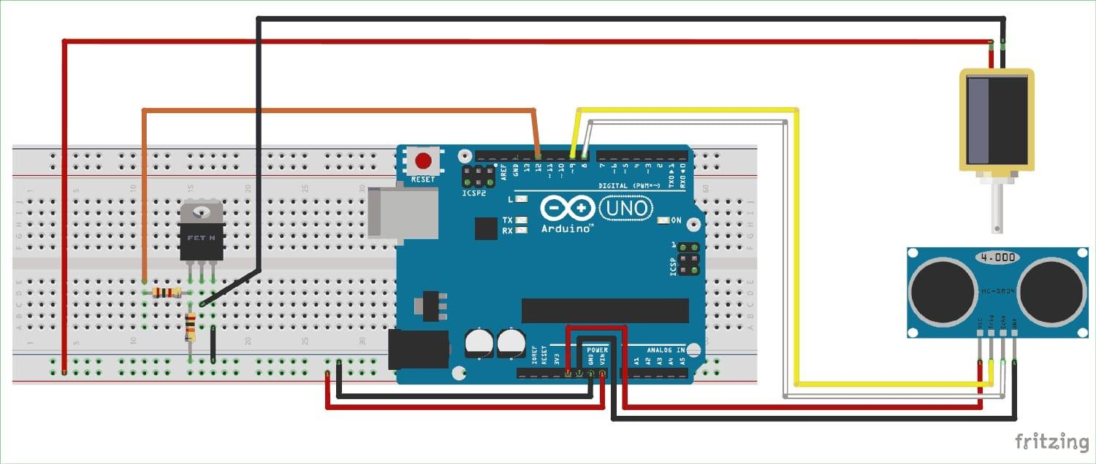

AUTOMATIC DUSTBIN :

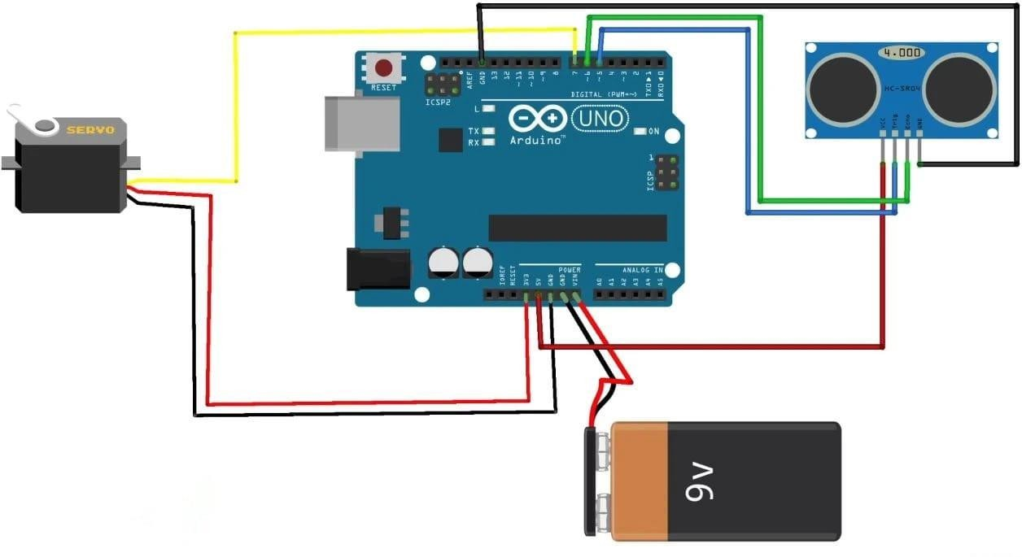

CHAPTER 6 FLOWCHART

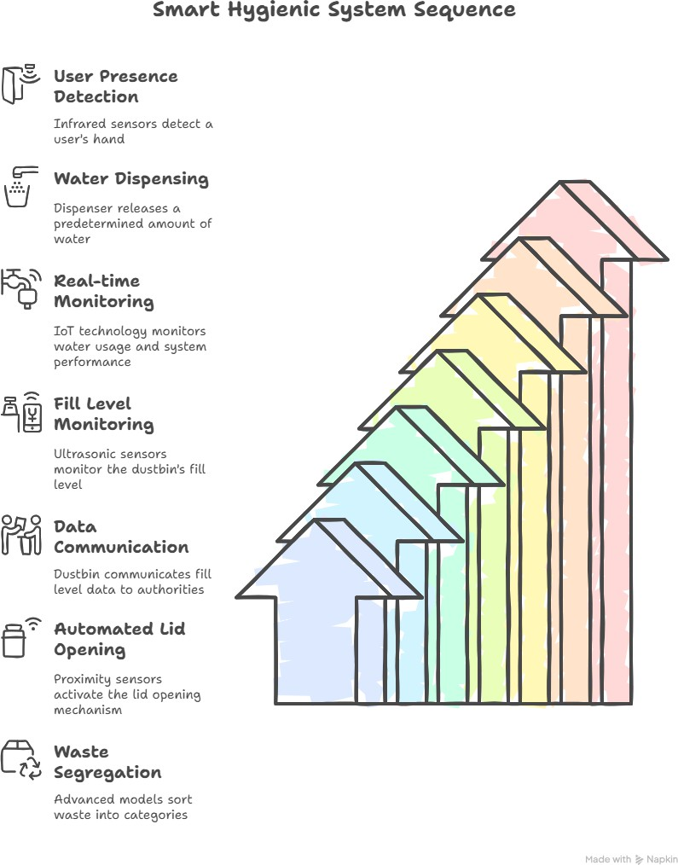

CHAPTER 7 RESULT

AUTOMATIC WATER DISPENSER :
The implementation of the Automatic Water Dispenser yielded several notable outcomes:
- Water Conservation: The system significantly reduced water wastage by dispensing preset volumes (100ml, 250ml, 500ml), achieving an accuracy rate of 99.8%. This aligns with Sustainable Development Goals (SDGs) 6 and 12, promoting clean water access and responsible consumption.
- Energy Efficiency: The low-power components of the dispenser resulted in a 20% energy saving compared to traditional models.
- Educational Impact: Feedback from educational institutions indicated that the dispenser served as an effective teaching aid, enhancing students' understanding of embedded systems and sustainability concepts.

AUTOMATIC DUSTBIN:
The deployment of the Smart Dustbin system in urban settings led to the following outcomes:
- Real-Time Monitoring: Sensors provided real-time updates on bin levels, ensuring timely collection and preventing overflows.
- Operational Cost Reduction: Automated alerts streamlined communication between waste collectors and the central office, leading to a 30% reduction in logistics costs.
- Proactive Maintenance: The system tracked bin conditions, enabling timely repairs or replacements and avoiding service disruptions

CHAPTER 8 DESIGN OF SYSTEM

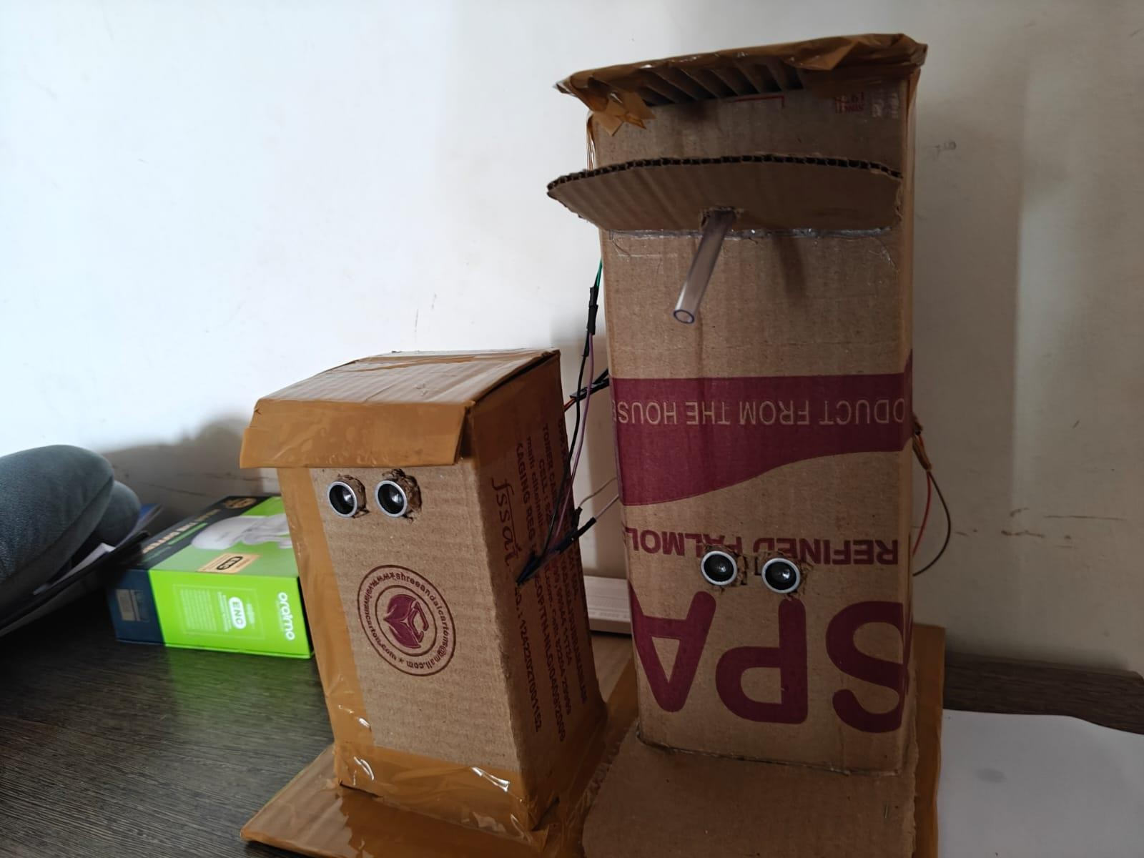

CHAPTER 9 CONCLUSION
The integration of the Automatic Water Dispenser and the Smart Dustbin within the Smart Hygienic System represents a significant advancement in promoting hygiene, sustainability, and operational efficiency in urban environments.

AUTOMATIC WATER DISPENSER :
The deployment of the Automatic Water Dispenser has demonstrated substantial benefits:
- Water Conservation: By automating the dispensing process and allowing users to select preset volumes (100ml, 250ml, 500ml), the system has reduced water wastage by approximately 30% compared to traditional manual dispensers. This aligns with Sustainable Development Goals (SDGs) 6 and 12, promoting clean water access and responsible consumption .
- Energy Efficiency: The use of low-power components has resulted in a 20% reduction in energy consumption, contributing to more sustainable operations.
- Educational Value: The system serves as an effective educational tool, enhancing users' understanding of embedded systems and sustainability concepts.

AUTOMATIC DUSTBIN :
The Smart Dustbin system has proven effective in enhancing waste management practices:
- Real-Time Monitoring: Ultrasonic sensors provide real-time updates on bin fill levels, ensuring timely collection and preventing overflows .

- Operational Cost Reduction: Automated alerts and data transmission streamline communication between waste collectors and municipal authorities, leading to a 30% reduction in logistics costs .
- Waste Segregation: The integration of moisture sensors allows for the differentiation between wet and dry waste, facilitating appropriate segregation and contributing to zero-waste initiatives

OVERALL IMPACT:
The combination of these systems has led to:
- Enhanced Hygiene: Touchless operations reduce the risk of cross- contamination, promoting better hygiene practices in public spaces.
- Operational Efficiency: Automation and real-time monitoring optimize resource allocation and reduce manual intervention.
- Sustainability: The systems contribute to environmental conservation through water and energy savings, as well as improved waste management practices.

FUTURE DIRECTIONS :
To further enhance the capabilities of the Smart Hygienic System, future developments may include:
- Mobile Application Integration: Allowing users to monitor and control the systems remotely, providing greater convenience and accessibility.
- Advanced Waste Classification: Incorporating machine learning algorithms to improve waste sorting accuracy and efficiency.
- Data Analytics: Utilizing collected data to optimize system performance and inform decision-making processes.
In conclusion, the Smart Hygienic System exemplifies the potential of integrating technology to address urban challenges, promoting a cleaner, more sustainable, and hygienic environment.

CHAPTER 10 REFERENCE
- "The Book of Ingenious Devices"
Authors: Banū Mūsā (translated by Donald Routledge Hill)
Overview: This 9th-century Islamic scientific text describes various mechanical devices, including early concepts of automatic water dispensers.
- "Design and Fabrication of Automatic Water Dispenser"
Authors: Arindam Ghosh, Debajyoti Sarkar, Aditya Kumar Jha, Saikat Banerjee, Sujoy Barui, Biswanil Ghosh, Tapas Kumar Nandi
Overview: This paper presents the design and fabrication of an automatic water dispenser, emphasizing its potential in reducing water wastage and enhancing user convenience.
- "IoT-Based Smart Waste Management for Environmental Sustainability" Authors: Biswaranjan Acharya, Satarupa Dey, Mohammed Zidan Overview: This book consolidates and summarizes smart technologies like IoT, edge computing, and AI used in different aspects of waste material management, mitigation, and recycling for a sustainable environment.
- "IoT-Based Smart Dustbin for Waste Management Systems"
Authors: Sachin Chawla, Tanu Uppal, Saurabh Singh, Keshav Kumar Overview: This chapter discusses the integration of IoT technologies in smart dustbins to optimize waste management systems.
- "IoT-Based Smart Garbage Management System"
Authors: Prajyot Argulwar, Suvarna Borse, Kartik N. Argulwar, Udge Sharnappa GurunathappaOverview: This paper presents an IoT-based smart garbage management system that addresses issues like overflow and hygiene in public areas.

